العاب البازل
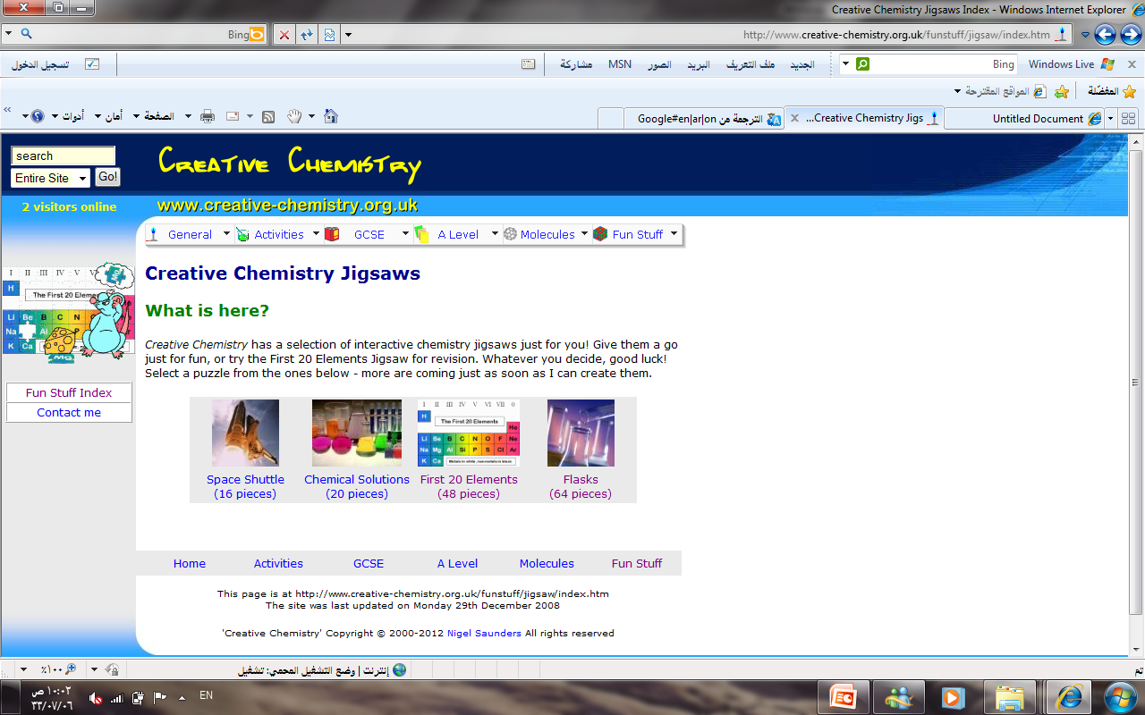
يتم اختيار اللعبة حسب الشكل و يتم الضغط عليها مع ملاحظة عدد القطع بين الاقواس حيث كلما زاد عدد القطع كلما ازدات الصعوبة .

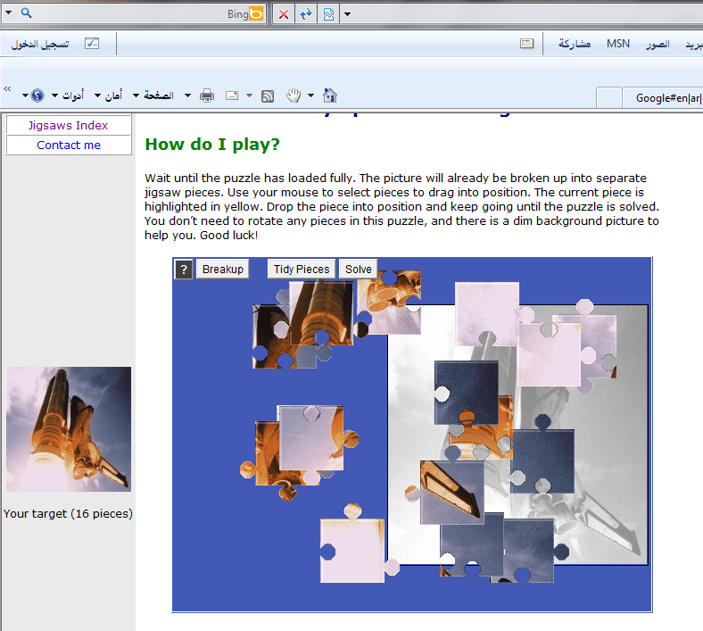
رابط اللعبة
http://www.creative-chemistry.org.uk/funstuff/jigsaw/index.htm

